(1:17) The Electoral College and the Founders Fear of Democracy
Source: Daily Kos

2016 Election Results
 | Electoral Votes | Popular Votes
Hillary Clinton (DEM) | 232 | 65,853,625 votes (48.0%)
Donald Trump (REP) | 306 | 62,985,106 votes (45.9%)

Questions to Consider
1. Why was Donald Trump declared the winner of the 2016 Presidential election?
2. According to the map, which candidate won the most states?
3. Which areas on the country more heavily supported Donald Trump?
4. Which areas of the country more heavily supported Hillary Clinton?
5. Do you support the current Electoral College system? Explain.
6. In your opinion, is it likely the Presidential election system will be changed? Explain.

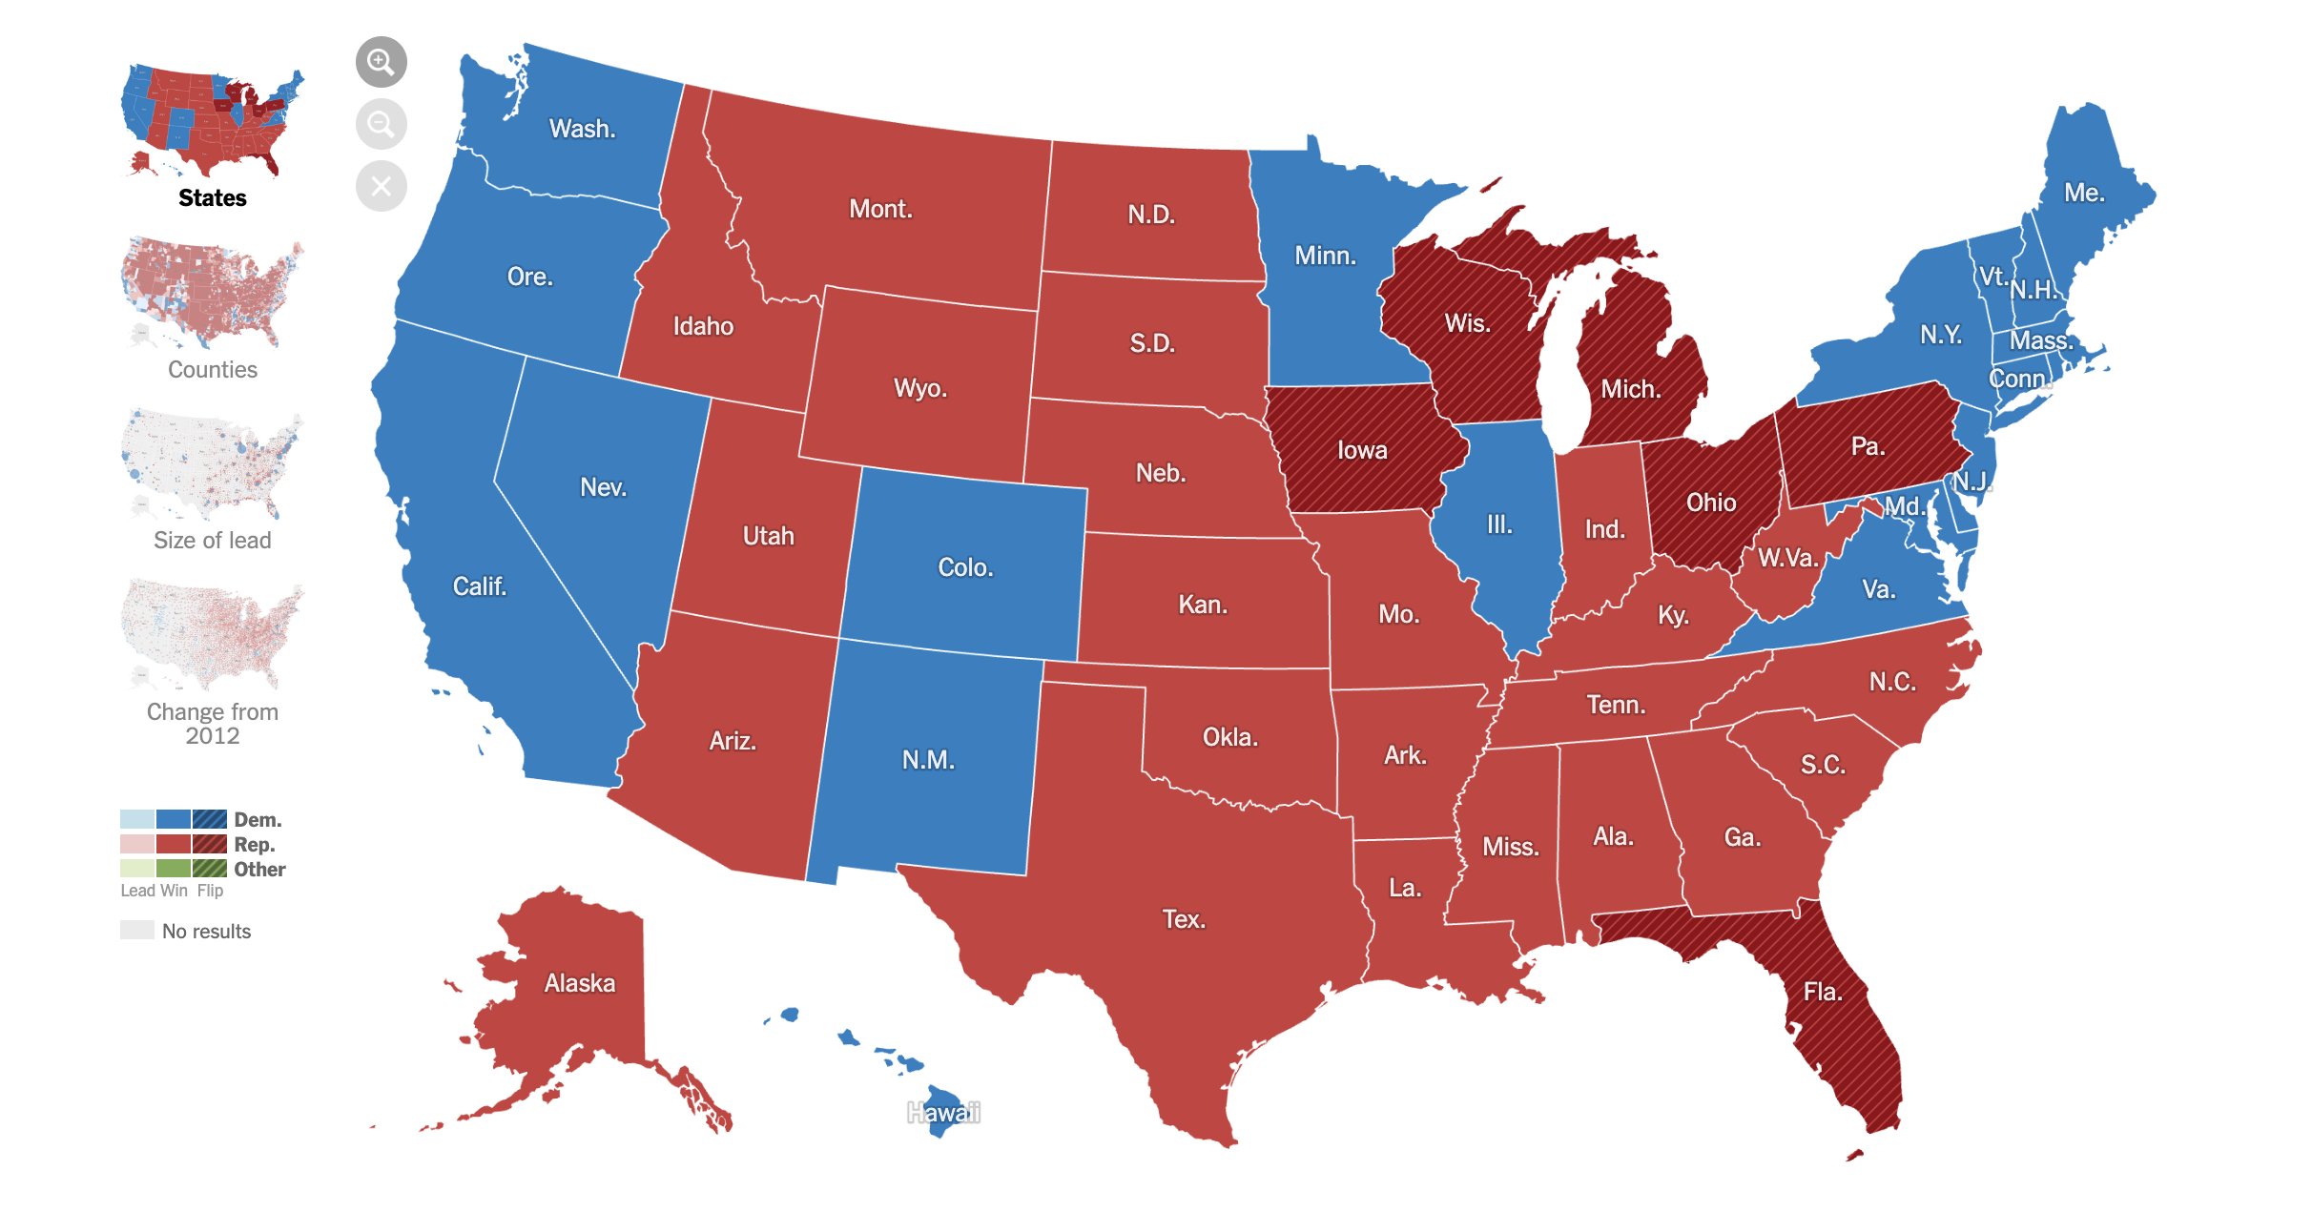

2020 Election

The Electoral College met” on Monday December 14, 2020, to certify the election of Joseph Biden as the 46th President of the United States. In 2016, Hillary Clinton had more votes than Donald Trump, but Trump was awarded the presidency because of the Electoral College. The same thing happened in 2000 when George Bush was awarded the presidency over Al Gore. Speculation on eliminating the Electoral College spiked as people watched Joe Biden’s vote total climb but the election still hinged on the Electoral votes of a few disputed states.

But eliminating the Electoral College ain’t going to happen.

First, a bit about how the Electoral College works, and then a little about its history.

Every four years the United States has 51 Presidential elections, one in each state and Washington DC. Except for Maine and Nebraska, whoever wins the state, gets all of its Electoral votes. States have electoral votes equal to their total of Congressional Representations and Senators. Wyoming has 3. California has 55. New York has 29.

The Electoral College was written into the Constitution because the founding fathers were scared of majority rule and wanted to protect slavery. James Madison clarified how the new government was designed to insulate the propertied few from majority rule in Federalist Paper #10 and Alexander Hamilton explained the functioning of the Electoral College in Federalist Paper #68.

In Federalist #10, Madison describes the new government created under the Constitution as a Republic, not a democracy, and argues that this would protect the “liberty,” meaning property, of the wealthy. “AMONG the numerous advantages promised by a well-constructed Union, none deserves to be more accurately developed than its tendency to break and control the violence of faction . . . By a faction, I understand a number of citizens, whether amounting to a majority or a minority of the whole, who are united and actuated by some common impulse of passion, or of interest, adversed to the rights of other citizens, or to the permanent and aggregate interests of the community.” According to Madison, majority factions, democracy, would be controlled in the new country by “substitution of representatives whose enlightened views and virtuous sentiments render them superior to local prejudices and schemes of injustice.”

In Federalist #68, Hamilton supports the new Constitution because “the immediate election” of the President will be “made by men most capable of analyzing the qualities adapted to the station, and acting under circumstances favorable to deliberation, and to a judicious combination of all the reasons and inducements which were proper to govern their choice,” a procedure that will “afford as little opportunity as possible to tumult and disorder.” Hamilton believed “The process of election affords a moral certainty, that the office of President will never fall to the lot of any man who is not in an eminent degree endowed with the requisite qualifications,” such as a commitment to ensure the wealth of the few is protected from everyone else.

The authors of the Constitution had other reasons they did not want the popular election of the President. If there were a straight up election, every state that wanted to improve its position would expand the franchise and encourage people to vote, maybe even women and men without property. To ensure there no bonus for increasing the eligible voters and voter turnout, states were assigned points based on their population, the number of members in the House of Representatives with two extra Electoral votes, no matter how many people were allowed to vote. This system also benefited states with few people.

The South wanted enslaved Africans to added to their point total, but they definitely were not going to allow them to vote. To protect the power of the slave states and to make it harder for the national government to interfere with slavery, every five enslaved Africans were counted as three people, giving Southern white planters extra representation in Congress and in the Electoral College. Because of this slaveholders won ten of the first 12 Presidential elections.

Today it is impossible to get rid of the Electoral College. It would require a Constitutional Amendment approved by 2/3 of the House, 2/3 of the Senate, and 3/4 of the states. But the small states, the Republican states, the states that suppress minority voting, and the overwhelmingly white states would never approve it because it would lessen their hold on the federal government. It is a racist system, it is an anti-democratic system, and because it is written into the Constitution, it ain’t going away.

