(2:6) Mansa Musa’s Hajj to Mecca (1324 AD)
Source: N. Levitzion and J. Hopkins (1981). Corpus of Early Arabic Sources for West African History (Cambridge University Press) pp. 269-273

Background: On their pilgrimage to Mecca to complete the Hajj, Mansa Musa, the King of Mali, and his entourage of an estimated 60,000 people including 12,000 slaves, stopped in Cairo. The trip to Mecca across the Sahara along caravan routes was at least 6,000 miles long. This description of their visit was written by ibn Fadlallah al-Umari based on discussions with people who witnessed the event. Because of the salt and gold trade across the Sahara, Mansa Musa may have been the wealthiest individual who ever lived. The map below showing an image of Mansa Musa is from the Catalan Atlas created in what is present day Spain in 1375.

Questions to Consider
1. Where was Mansa Musa and his entourage traveling to?
2. Why was their stopover in Cairo so memorable?
3. What was the impact of their stay in Cairo?
4. In your opinion, what can we conclude about Africa, the Islamic world, and the Medieval period from the story of Mansa Musa?

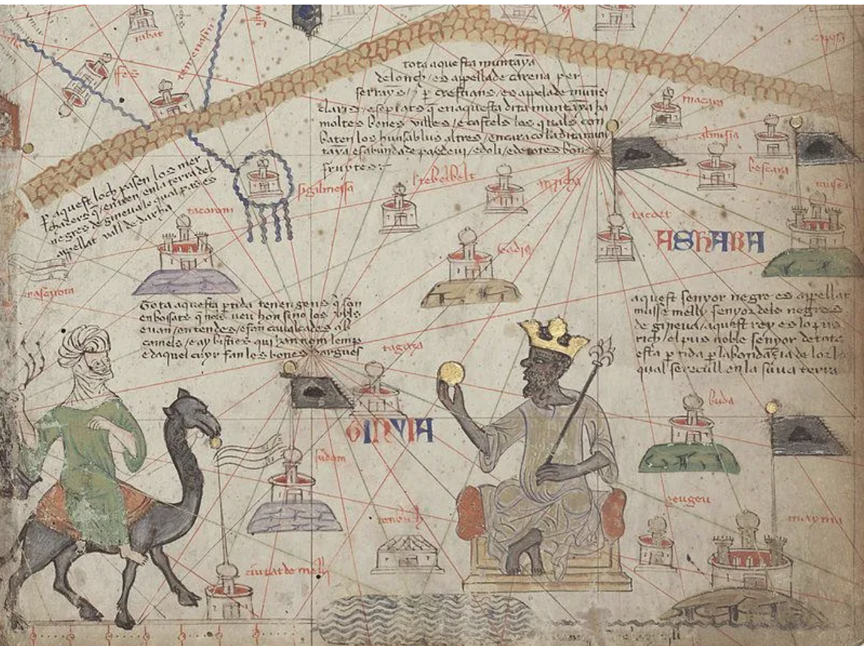

Catalan Atlas map caption: “His black Lord is called Musse Melly and is the sovereign of the land of the black people of Gineva. This king is the richest and noblest of all these lands due to the abundance of gold that is extracted from his lands.”

A. From the beginning of my coming to stay in Egypt I heard talk of the arrival of this sultan Musa on his Pilgrimage and found the Cairenes eager to recount what they had seem of the Africans’ prodigal spending. I asked the emir Abu . . . and he told me of the opulence, manly virtues, and piety of his sultan. “When I went out to meet him . . . on behalf of the mighty sultan al-Malik al-Nasir, he did me extreme honor and treated me with the greatest courtesy. He addressed me, however, only through an interpreter despite his perfect ability to speak in the Arabic tongue. Then he forwarded to the royal treasury many loads of unworked native gold and other valuables. I tried to persuade him to go up to the Citadel to meet the sultan, but he refused persistently saying: “I came for the Pilgrimage and nothing else. I do not wish to mix anything else with my Pilgrimage.”

B. This flooded Cairo with his benefactions. He left no court emir nor holder of a royal office without the gift of a load of gold. The Cairenes made incalculable profits out of him and his suite in buying and selling and giving and taking. They exchanged gold until they depressed its value in Egypt and caused its price to fall” . . . Gold was at a high price in Egypt until they came in that year. The mithqal did not go below 25 dirhams and was generally above, but from that time its value fell, and it cheapened in price and has remained cheap till now. The mithqal does not exceed 22 dirhams or less. This has been the state of affairs for about twelve years until this day by reason of the large amount of gold which they brought into Egypt and spent there.”

